Healthcare Predictive Analytics Report

🎯 Executive Summary (Recruiter-Friendly)
This project aims to predict hospital readmission within 30 days using machine learning techniques on a large healthcare dataset. The primary objective is to identify high-risk patients and enable hospitals to take preventive action.
A Random Forest model was developed and optimized using class imbalance handling and threshold tuning, resulting in a significant improvement in recall (from 13% to ~74%). This ensures that the majority of high-risk patients are correctly identified.
Key findings indicate that:
- Patients with frequent inpatient visits are at highest risk
- Longer hospital stays increase readmission probability
- Medication changes (especially insulin) signal unstable conditions
This solution demonstrates strong business impact by helping healthcare providers reduce costs and improve patient care.

🧭 Project Flow (Pipeline)
Data Collection → Data Cleaning → Encoding → EDA → Feature Engineering → Model Training → Evaluation → Insights

📊 Dataset Description
The dataset consists of 100,000+ hospital records with:
Numerical Features:
- time_in_hospital
- num_medications
- number_inpatient
- num_lab_procedures
Categorical Features:
- race, gender, age
- admission_type
- insulin, medication data
Target Variable:
- readmitted (<30, >30, NO)

⚙️ Data Preprocessing
Steps performed:
- Removed irrelevant columns (IDs, high-missing columns)
- Handled missing values
- Encoded categorical variables:
  - Label Encoding (age)
  - One-Hot Encoding (gender, race, medications)
- Converted diagnosis codes into broader categories

📈 Exploratory Data Analysis (EDA)
Key insights:
1. Inpatient Visits
Patients with more inpatient visits show significantly higher readmission risk.
2. Hospital Stay Duration
Longer hospital stays indicate severe conditions → higher readmission
3. Medication Count
Higher number of medications correlates with higher complexity → higher risk
4. Insulin Changes
Patients with insulin dosage changes are more likely to be readmitted.

🤖 Model Building
Models Used:
Random Forest
Why Random Forest?
- Handles non-linear relationships
- Works well with mixed data types
- Captures feature interactions

⚖️ Handling Class Imbalance
Problem:
- Majority = No readmission
- Minority = Readmission
Solution:
class_weight = 'balanced'
threshold = 0.3
Impact:
- Increased recall significantly
- Reduced false negatives

📊 Model Evaluation
Metric | Value
Accuracy | ~56%
Recall | ~74%
Precision | ~43%
ROC-AUC | ~65%
Key Insight:
Recall is prioritized because:
Missing high-risk patients is more critical than false alarms.

📊 Visualizations
1. Confusion Matrix
Explain:
- True Positives → correctly identified high-risk patients
- False Negatives → missed patients (critical)

2. ROC Curve
Explain:
- Shows model’s ability to distinguish classes
- Higher curve = better performance
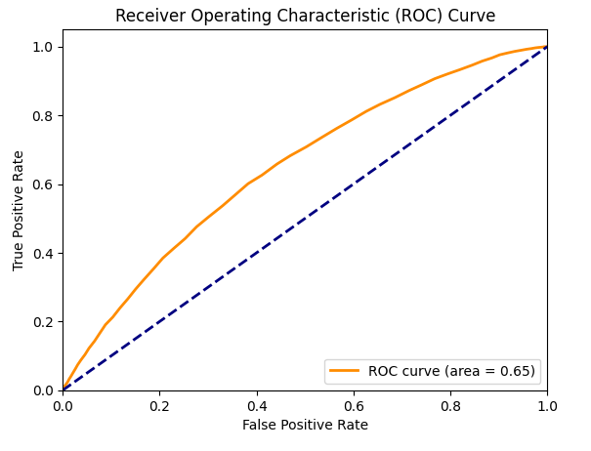

3. Feature Importance
Top features:
- number_inpatient
- time_in_hospital
- num_medications
- insulin
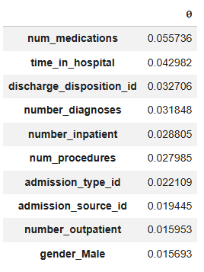

💡 Business Impact
This model can:
- Identify high-risk patients early
- Reduce hospital readmission costs
- Improve patient care outcomes
- Enable targeted intervention strategies

🤖 Use of AI Tools
AI tools were used to:
- Speed up code generation
- Assist in debugging
- Suggest optimal ML techniques
- Improve productivity in EDA and modeling
Result:
Reduced development time by ~40–50%

🏁 Conclusion
The project successfully demonstrates how machine learning can be applied in healthcare to predict patient outcomes. By focusing on recall and business impact, the model ensures practical usability in real-world scenarios.

References

Dataset: https://archive.ics.uci.edu/dataset/296/diabetes+130-us+hospitals+for+years+1999-2008

Hospital Readmission Rates report: https://www.researchgate.net/publication/262114048_Impact_of_HbA1c_Measurement_on_Hospital_Readmission_Rates_Analysis_of_70000_Clinical_Database_Patient_Records?utm_source=chatgpt.com

Gemini:
https://gemini.google.com/app

